# [**解决使用pip安装时报错Could not fetch URL https://pypi.org/simple/tensorflow/: There was a problem confirmi...**](https://my.oschina.net/u/4260786/blog/4422497)



|  |
| --- |
| root@zhou-virtual-machine:~# pip install docker-compose  pip is configured with locations that require TLS/SSL, however the ssl module in Python is not available.  Collecting docker-compose  Could not fetch URL https://pypi.python.org/simple/docker-compose/: There was a problem confirming the ssl certificate: Can't connect to HTTPS URL because the SSL module is not available. - skipping  Could not find a version that satisfies the requirement docker-compose (from versions: )  No matching distribution found for docker-compose |

解决办法

|  |
| --- |
| pip install package_name -i http://pypi.douban.com/simple --trusted-host pypi.douban.com |

可替换用的镜像源

1)[http://mirrors.aliyun.com/pypi/simple/](https://www.oschina.net/action/GoToLink?url=http%3A%2F%2Fmirrors.aliyun.com%2Fpypi%2Fsimple%2F) 阿里云  
2)[https://pypi.mirrors.ustc.edu.cn/simple/](https://www.oschina.net/action/GoToLink?url=https%3A%2F%2Fpypi.mirrors.ustc.edu.cn%2Fsimple%2F) 中国科技大学  
3)[http://pypi.douban.com/simple/](https://www.oschina.net/action/GoToLink?url=http%3A%2F%2Fpypi.douban.com%2Fsimple%2F) 豆瓣  
4)[https://pypi.tuna.tsinghua.edu.cn/simple/](https://www.oschina.net/action/GoToLink?url=https%3A%2F%2Fpypi.tuna.tsinghua.edu.cn%2Fsimple%2F) 清华大学  
5)[http://pypi.mirrors.ustc.edu.cn/simple/](https://www.oschina.net/action/GoToLink?url=http%3A%2F%2Fpypi.mirrors.ustc.edu.cn%2Fsimple%2F) 中国科学技术大学

Url: <https://my.oschina.net/u/4260786/blog/4422497>

# **Python3.8 ModuleNotFoundError: No module named 'setuptools_rust'**

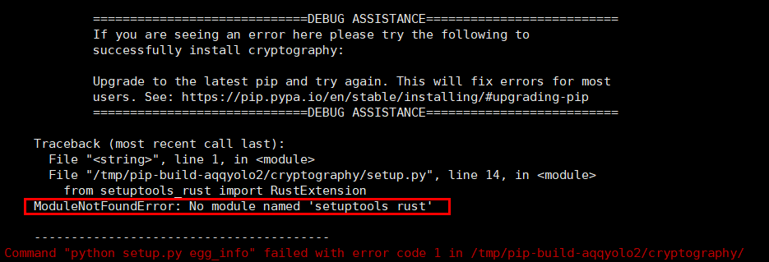

pip install --upgrade pip

https://www.jianshu.com/p/5ccd821bc595